**Detection of covid-19 and pneumonia using**

**deep learning**

*P. Kalaivani* *Department of Computer Science and Engineering   
 Kongu Engineering College  
 Erode, India* [*kalaivanip.cse@kongu.edu*](mailto:kalaivanip.cse@kongu.edu)

*S. Bharathi   
Department of Computer Science and Engineering  
Kongu Engineering College  
Erode, India*[*bharathisanmugaraj@gmail.com*](mailto:bharathisanmugaraj@gmail.com)

*C . Rajan*

*Department of Information Technology*

*K.S Rangasamy College of Technology*

*Namakkal, India*

[*rajancsg@gmail.com*](mailto:rajancsg@gmail.com)

*A. Dhivya*

*Department of Computer Science and Engineering*

*Kongu Engineering College*

*Erode, India* [*dhivya.arumugam28@gmail.com*](mailto:dhivya.arumugam28@gmail.com)

*G. Dharani  
Department of Computer Science and Engineering  
Kongu Engineering College  
Erode, India  
dharanigopal30@gmail.com*

***Abstract: -*** *The survival percentage of lung patients can be improved by early diagnosis of pneumonia disease and Covid-19. The main method for identifying and diagnosing pneumonia and Covid19 is through chest X-ray (CXR) pictures. It can be difficult for a professional radiologist to identify pneumonia and Covid-19 from CXR images. Covid-19 has a significant change in circumstances that led to a major epidemic and had an impact on the stability and well-being of the planet. Deep learning (DL) techniques have recently been proposed for the development of automated detection models. It currently plays an important part in the field of medical imaging and image classification. Our project investigates the problem statement as automation of separating COVID-19 infected people from normal healthy people using chest X-rays. In the current work, various CNN models were employed to detect differences in chest X-rays, with high accuracies. Our project proposes a new approach for classifying chest X- rays images that use multi classification using pre-processing techniques such as histogram equalization and bilateral filtering with different dataset.The architecture of the proposed model are VGG16 and InceptionV3 are used for multi classification. It makes use of auxiliary Classifiers as it regularises .VGG16 attained accuracy of 88%, InceptionV3 attained the highest accuracy with 93%. All of these architectures’ performances are compared using different classification metrics.*

***Keyword --*** *Covid-19, Pneumonia, CNN- Convolutional Neural Network, VGG- Visual Geometry Group Network, InceptionV3.*

# **I**. **INTRODUCTION DETECTION OF PNEUMONIA**

A lung infection known as pneumonia is brought on by bacteria, viruses, or fungi. Based on the x-rays that were collected, our project is to identify the lung illness. A sudden, high fever and chills are the classic symptoms of pneumonia. Infections primarily brought on by bacteria or viruses, and less frequently by fungi and parasites, result in pneumonia. The majority of the time, pneumonia is brought on by microorganisms that are inhaled (aspirated) from upper airways into the lungs, but it can also be brought on by an imbalance between the microorganisms that inhabit the airways and lungs or that directly infect the lungs from another infection site close by. Within a few hours, people with pneumonia begin to feel really sick. However, it can start out slowly and just have a few, moderate symptoms, especially in older persons.

# **DETECTION OF COVID**

The SARS-CoV-2 virus causes coronavirus disease, which is an infectious disease. It belongs to the coronavirus family, which also includes viruses that cause more serious disorders such as Middle East respiratory syndrome (MERS) and severe acute respiratory syndrome (SARS). Droplets released when an infected individual coughs, sneezes, or speaks are the major means of transmission for this. A person can contract the coronavirus from another individual. A test is used to diagnose it. The severity of the infection will determine how COVID-19 is treated. Resting at home and taking medication to lower the fever usually suffices for lesser illnesses. As with the delta and omicron versions, mutations may make it possible for the coronavirus to spread more quickly from person to person. More infections can lead to more people being seriously ill, as well as more chances for the virus to evolve new mutations.

# **DIAGNOSIS OF PNEUMONIA**

A pleural fluid culture, in which the physician takes a tiny amount of fluid from the tissues surrounding your lungs in order to check for germs that could potentially cause pneumonia. Measures the amount of oxygen in a little amount of blood drawn from one of your arteries during an arterial blood gas test. Bronchoscopy to check for obstructions or other issues in your airways , a CT scan to obtain a more thorough picture of your lungs. If you fall into one of the high-risk for children under the age of two, or those with an underlying medical condition or impaired immune system, it is very crucial that you seek medical assistance for pneumonia. Pneumonia has the potential to swiftly become a life-threatening condition for some of these susceptible people. White spots on an X-ray may be signs of bacterial pneumonia. Other pathological characteristics, such as fluid encircling the lungs (pleural effusion) or abscesses, can also be seen in the imaging.

# **DIAGNOSIS OF COVID 19**

Reverse Transcription Polymerase Chain Reaction for infected secretions can be used to confirm a tentative diagnosis of COVID-19 based on symptoms. Chest CT scans may be useful in conjunction with laboratory tests to diagnose COVID-19 in patients with a high clinical suspicion of infection. Serological tests, which look for antibodies the body produces in response to an infection, can identify a previous illness. Depending on where you reside, different criteria may be used to determine whether or not to test you for the virus that causes COVID-19. Your clinic may need to screen you in order to decide whether testing is necessary and accessible for you given your location. After that, the samples are taken to a lab for analysis. Sputum from your cough may be submitted for analysis. The COVID-19 virus can now be tested for at-home by the FDA. These can only be obtained with a prescription from a doctor.

# **DEEP LEARNING**

Deep learning is a form of mimic of the human brain, much like Artificial Neural Networks are. A branch of Machine Learning called "deep learning" is solely dependent on neural networks. The concept of deep learning is not new. It has been around for some time. Accessing more data and computational power than the procedure had in the past, it is more common now. Over the past 20 years, processing power has grown exponentially, which has led to the development of deep learning and machine learning. Deep learning is formally defined as neurons.

# **CONVOLUTIONAL NEURAL NETWORK**

Convolutional neural networks (CNN), a particular kind of deep learning architecture, are designed for certain tasks like classifying images. An input layer is one of the components of a CNN. However, the input for fundamental image processing typically consists of image's pixel values which is a two dimensional array of neurons. It also has an output layer, which is made up of a single dimensional array of output neurons. CNN processes the incoming images by combining convolution layers with sparse connections. They also include down sampling levels known as pooling layers used to reduce the number of neurons required in subsequent layers of network.

# **VGGNET ARCHITECTURE 1**

VGG architecture, were VGG denotes for Visual Geometry Group, refers to a deep convolutional neural network design that contains several layers. The layers were referred to as deep and VGG-16 or 19, that are having 16 or 19 layers. Inventive item identification models are created using the VGG architecture. The VGGNet, has formed as a deep neural network, performs benchmarks on a variety of datasets other than ImageNet. Furthermore, it is the most widely and commonly used image recognition architectures currently.

# **VGG16**

The VGG model, also known as VGGNet, is a 16layer convolutional neural network model that is commonly abbreviated as VGG16. The model which these researchers released is defined as “Deep Convolutional Networks for Large Scale Image Recognition". ImageNet is a dataset with over 14 million images arranged into about 1000 sections. It also performed well in comparison to other models submitted to ILSVRC-2014. It outclasses AlexNet by using many 3x3 kernel-sized filters instead of the massive kernel-sized filters. Over the course of several weeks, Nvidia Titan Black GPUs were used to train the VGG16 model. The previously mentioned 16-layer VGGNet-16 can classify photos into 1000 different object classifications, such as animals, pencil, mouse, and many more. Chest X rays with a resolving of 224 x 224 are also supported by the model.

# **INCEPTIONV3**

Convolutional Neural Networks are a deep learning method for categorizing images called Inception V3. The basic model V1 of Inception, which was first made available in 2014 as Google Net, has been upgraded into the more complex Inception V3. When a model has numerous thick layers of convolutions, the data became overfit. The conception V1 model uses the idea of numerous on the same level, filters of different sizes to get around this. As a result, inception models use parallel layers rather than deep layers, which results in a larger model than a deeper one.

The inception V3 model is simply the inceptionV1 model with improvements. The InceptionV3 model optimizes the network using a variety of techniques for enhanced model adaptability. It yields better results. Compared to the Inception V1 and V2 models, it has a larger network, but its speed is unaffected. In terms of computing, it is less expensive. It makes use of auxiliary Classifiers as it regularizes.

# **ii. EXISTING SYSTEM**

Most research domains have used machine learning and deep learning techniques. Deep Learning is a component of machine learning that helps create intelligent solutions to complex problems. Artificial neural networks are used in deep learning to examine data and create predictions. Almost all corporate sectors have used it. However, they need a lot of data, a lot of processing power, and not a lot of resources. In addition, for smart various applications to enable and assist their services, developed systems must be secure and have high energy efficiency.

In terms of accuracy and efficiency, medical healthcare systems are one of these applications that needs improvement. In existing, the dataset is trained as two binary classification without preprocessing. A CNN architecture is made up of a stack of unique layers that, by using a differentiable function, convert the input volume into an output volume (such as keeping the class scores). There are several uses for CNN, including medical imaging, object identification, and picture classification. VGGNet, ZFNet, and Alexnet, are three CNN models for classification of image that excel in practical applications. In existing, the covid x CT 1,94,922 chest X-ray slices from 3,745 patients are trained as hybrid binary classification without preprocessing with greater accuracy. There are two phases: The accuracy in the first phase, used the DenseNet-201 structure to separate the covid and normal CT slides, which was high and the accuracy of the second phase which used the InceptionV3 architecture to classify Normal and Pneumonia CT slices was greater. The data are divided into Covid and Pneumonia categories using the Phase-1 model. The phase-2 model may categorize Pneumonia pictures after phase 1 into groups of either normal or pneumonia. Consequently, phase 1 and 2 both undergoes classification.

Rajpurkar , Pranav, and Jeremy Irvin , trained CheXNet on the recently released Chest X-ray14 dataset to expert-level automation, wishing that this technology is improving healthcare delivery and increase access to medical image analysis, particularly X-rays. The retrained model is then analyzed by comparing the results to state-of-the-art approaches. Creating an algorithm that identifies the disease pneumonia from anterior chest X-ray images to a level that exceeds the abilities of practicing radiologists.

**III. PROPOSED SYSTEM**

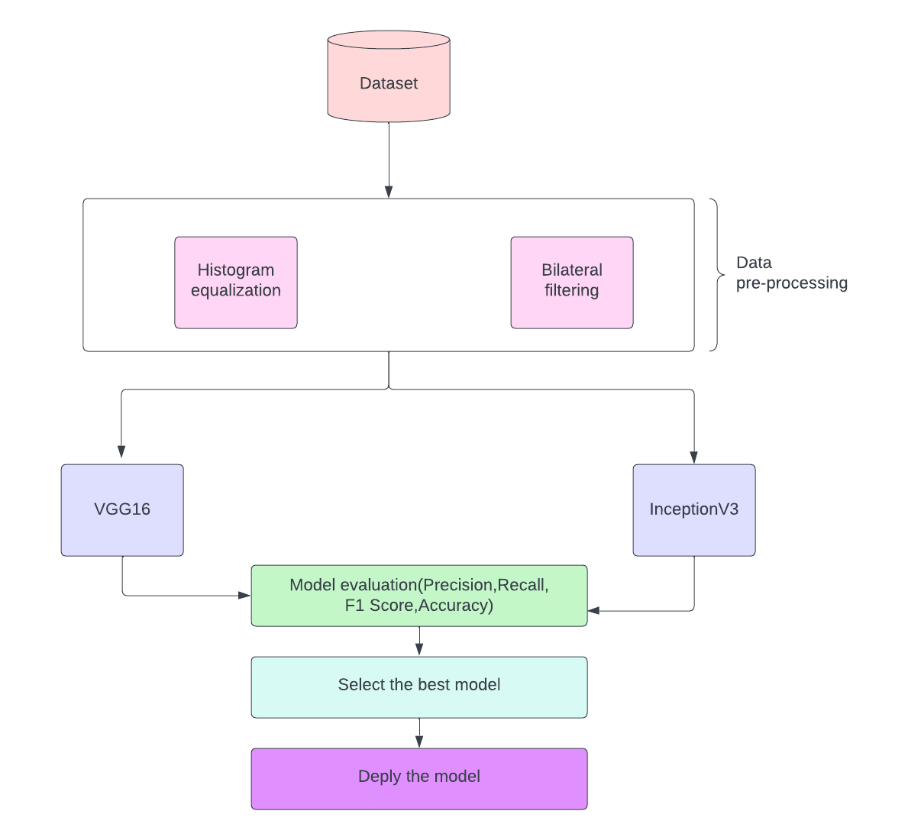

Fig .1 Proposed model

## **IV. DATASET**

The first and most important duty in each application is dataset collection. Here are a few procedures to follow when gathering datasets.

**CHEST X RAY IMAGES**

The dataset are collected from Kaggle (https://www.kaggle.com/datasets/anasmohammedtahir/covidqu) which consists of 33,920 chest X-ray (CXR) images. The datasets are in the form of images which refers the diseases such as covid19,Pneumonia and Normal. All images are in Portable Network Graphics format. Figure. 2 represents the normal chest x rays images of covid-19, normal, pneumonia.

Covid-19 Normal Pneumonia

Fig 2.Normal chest x-rays

**DATA PRE-PROCESSING**

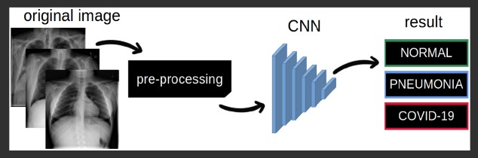

Fig.3 Model Image

## **HISTOGRAM EQUALIZATION**

A contrast-normalized image is produced using the histogram equalization technique that exclusively use authentic Chest X-ray pictures. The suggested approach is to manipulating the histogram before applying histogram equalization. The results suggested that the suggested strategy would be more effective than other common strategies for contrast enhancement. Future iterations of a approach may be more effective if the background is automatically removed before use.

Figure.4 the images that are preprocessed using histogram equalization are represented below.

Covid-19 Normal Pneumonia

Fig.4 Histogram Equalization chest X-rays

## **BILATERAL FILTERING**

The bilateral filter is a method for image smoothing that keeps edges clean. It solely depends on two factors that define the size and contrast of the features that should be preserved. According to the BF's formulation for noise reduction, each pixel is replaced by a weighted average of its neighbors, as is done, for reference, when an image is convoluted with a Gaussian filter. The concept of combining domain and range filtering is embodied by bilateral filtering. The authors come to the conclusion that the bilateral filter in image space significantly reduces noise while maintaining sharp edges. Figure.5 the images that are preprocessed using bilateral filtering are shown below.

Covid-19 Normal Pneumonia

Fig.5 Bilateral Filtering chest x-rays

## **V. PERFORMANCE METRICS**

Various parameters are employed during the evaluation, including

* Accuracy
* Precision
* Recall
* F1 Score

Some basic terms associated with performance evaluation are,

* True positive: A state where both the expected and actual values are positive.
* True negative: A state where the expected and actual values are opposite to each other.
* False Positive: A state in which the value expected is positive but the value actually obtained is negative.
* False Negative: A state where the actual value is positive and expected value is negative.

## **A**. **Accuracy**

Accuracy is one of the most important for analyzing the performance of the model. The ratio between the sum of true negative and true positive to the total

number of samples is the accuracy

No of correct predictions

Accuracy = --------------------------------- (1)

Total number of predictions

## **B. Precision**

The precision is calculated because of the quantitative relation between the variety of positive samples properly classified either properly or incorrectly to the full number of samples classified as positive. The precision measures the accuracy of a model in classifying a sample positive. The below equation depicts the formula for calculation of precision.

Precision = TP/(TP+FP) (2)

## **C. Recall**

The quantitative relationship between number of correctly identified Positive samples as well as the overall number of Positive samples is used to estimate recall. The recall is a metric that measures a model's capacity to recognize positive samples. The elevated the recall, the more positive samples are found.

Recall = TP/(TP+FN) (3)

## **D. F1 Score**

The F1 Score is the harmonic mean of both precisions. It achieves its maximum value of1(perfect precision and recall) and its minimum value of 0 respectively.

**VI. RESULTS AND DISCUSSION**

## **A. Accuracy**

Figure 6 displays the accuracy comparison of the DL approaches. Of all the algorithms, it has been demonstrated that the InceptionV3 is the most accurate. To increase the predictability of the dataset, InceptionV3 applies a number of perceptron layers to diverse subsets of the data and chooses the average. The dataset is categorization is determined by the perceptron layers, which combines several layers. As a result, it is shown that InceptionV3, based on testing accuracy, has the highest accuracy.

## ACCURACY COMPARISON

Fig.6 Accuracy Comparison

**B. Precision**

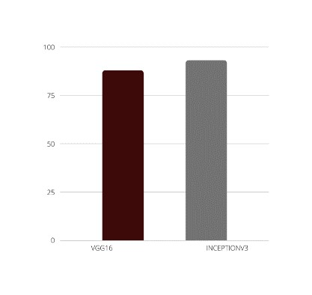*PRECISION COMPARISON*

Fig.7 Precision comparison

Figure 7 displays the precision comparison of the DL approaches. It is demonstrated that across all methods, the InceptionV3 Algorithm has the highest precision score. InceptionV3 employs a number of perceptron layers on various subsets of the data and averages the outcomes to improve the dataset is accuracy. The InceptionV3 blends various perceptron layers to forecast the dataset is class. In light of testing precision, it is shown that InceptionV3 has the highest precision score.

## **C. Recall**

Figure 8 displays the recall comparison of the DL approaches. The InceptionV3 algorithm has the highest recall of all the techniques. It employs a number of perceptron on various subsets of the data and averages the outcomes to improve the dataset is accuracy. For the purpose of predicting the dataset is class, the InceptionV3 combines several perceptron. As a result, it is demonstrated that InceptionV3 has the highest memory score based on the recall score.

## RECALL COMPARISON

Fig.8.Recall comparison

## **D. F1 Score**

The F1 Score comparison of the DL techniques is shown in Figure 9. Of all algorithms, InceptionV3 Algorithm has the highest f1 score. It employs a number of perceptron’s on various subsets of the data and averages the outcomes to improve the dataset is accuracy. The InceptionV3 blends various perceptron’s in order to forecast the dataset is class. As a result, it is demonstrated by the testing f1 score that InceptionV3 has the greatest f1 score.

## F1 SCORE COMPARISON

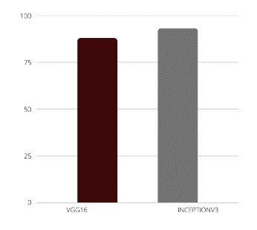

Fig.9 F1 Score comparison

## **VII. CONCLUSION AND FUTURE WORK**

CNN, VGG16, and InceptionV3 deep learning frameworks are used to develop diagnosis of Covid19, pneumonia, and standard categorization have used Multi classification. When Pneumonia classes have been classified to COVID images, our proposed model helped us decrease the number of incorrect predictions.

Patients should obtain verification from a qualified physicians or radiologist even though the model has more accurate and performs extraordinarily well; instead, they should rely on it only when absolutely necessary. Many researchers might find this study valuable in their work and it has room for improvement. This work can improve with high accuracy using hybrid multi classification. Even though the model is very precise and performs well, patients must seek assurance from a trained physicians or radiologist; instead, they should depend on it only when considered required. Many researchers may find this study useful in their work, but it could be improved. Using hybrid multi classification, this work can be improved with high accuracy.

# **REFERENCE**

1. [Meem, Anika Tahsin, et al. "Prediction of covid19 based on chest x-ray images using deep learning with CNN." Computer Systems Science and Engineering (2022): 1223-1240.](%5b1%5d%09Meem,%20Anika%20Tahsin,%20et%20al.%20%22Prediction%20of%20covid19%20based%20on%20chest%20x-ray%20images%20using%20deep%20learning%20with%20CNN.%22%20Computer%20Systems%20Science%20and%20Engineering%20(2022):%201223-1240.)
2. [Hammoudi, Karim, et al. "Deep learning on chest X-ray images to detect and evaluate pneumonia cases at the era of COVID-19." Journal of medical systems 45.7 (2021): 1-10.](%5b2%5d%09Hammoudi,%20Karim,%20et%20al.%20%22Deep%20learning%20on%20chest%20X-ray%20images%20to%20detect%20and%20evaluate%20pneumonia%20cases%20at%20the%20era%20of%20COVID-19.%22%20Journal%20of%20medical%20systems%2045.7%20(2021):%201-10.)
3. [Khan, Asif Iqbal, Junaid Latief Shah, and Mohammad Mudasir Bhat. "CoroNet: A deep neural network for detection and diagnosis of COVID-19 from chest x-ray images." Computer methods and programs in biomedicine 196 (2020): 105581.](%5b3%5d%09Khan,%20Asif%20Iqbal,%20Junaid%20Latief%20Shah,%20and%20Mohammad%20Mudasir%20Bhat.%20%22CoroNet:%20A%20deep%20neural%20network%20for%20detection%20and%20diagnosis%20of%20COVID-19%20from%20chest%20x-ray%20images.%22%20Computer%20methods%20and%20programs%20in%20biomedicine%20196%20(2020):%20105581.)
4. [Alghamdi, Hanan S., et al. "Deep learning approaches for detecting COVID-19 from chest Xray images: A survey." Ieee Access 9 (2021): 2023520254.](%5b4%5d%09Alghamdi,%20Hanan%20S.,%20et%20al.%20%22Deep%20learning%20approaches%20for%20detecting%20COVID-19%20from%20chest%20Xray%20images:%20A%20survey.%22%20Ieee%20Access%209%20(2021):%202023520254.)
5. [Yasar, Huseyin, and Murat Ceylan. "A new deep learning pipeline to detect Covid-19 on chest X-ray images using local binary pattern, dual tree complex wavelet transform and convolutional neural networks." Applied Intelligence 51.5 (2021): 27402763.](%5b5%5d%09Yasar,%20Huseyin,%20and%20Murat%20Ceylan.%20%22A%20new%20deep%20learning%20pipeline%20to%20detect%20Covid-19%20on%20chest%20X-ray%20images%20using%20local%20binary%20pattern,%20dual%20tree%20complex%20wavelet%20transform%20and%20convolutional%20neural%20networks.%22%20Applied%20Intelligence%2051.5%20(2021):%2027402763.)
6. [Vasuki, P., J. Kanimozhi, and M. Balkis Devi. "A survey on image preprocessing techniques for diverse fields of medical imagery." *2017 IEEE International Conference on Electrical, Instrumentation and Communication Engineering (ICEICE)*. IEEE, 2017.](%5b6%5d%09Vasuki,%20P.,%20J.%20Kanimozhi,%20and%20M.%20Balkis%20Devi.%20%22A%20survey%20on%20image%20preprocessing%20techniques%20for%20diverse%20fields%20of%20medical%20imagery.%22%202017%20IEEE%20International%20Conference%20on%20Electrical,%20Instrumentation%20and%20Communication%20Engineering%20(ICEICE).%20IEEE,%202017.)
7. [Bhadouria, Hitendra Singh, et al. "Classification of COVID-19 on chest X-Ray images using Deep Learning model with Histogram Equalization and Lungs Segmentation." *arXiv preprint arXiv:2112.02478* (2021).](%5b7%5d%09Bhadouria,%20Hitendra%20Singh,%20et%20al.%20%22Classification%20of%20COVID-19%20on%20chest%20X-Ray%20images%20using%20Deep%20Learning%20model%20with%20Histogram%20Equalization%20and%20Lungs%20Segmentation.%22%20arXiv%20preprint%20arXiv:2112.02478%20(2021).)
8. [Chhikara, Prateek, et al. "Deep convolutional neural network with transfer learning for detecting pneumonia on chest X-rays." *Advances in bioinformatics, multimedia, and electronics circuits and signals*. Springer, Singapore, 2020. 155-168.](%5b8%5d%09Chhikara,%20Prateek,%20et%20al.%20%22Deep%20convolutional%20neural%20network%20with%20transfer%20learning%20for%20detecting%20pneumonia%20on%20chest%20X-rays.%22%20Advances%20in%20bioinformatics,%20multimedia,%20and%20electronics%20circuits%20and%20signals.%20Springer,%20Singapore,%202020.%20155-168.)
9. [Heidari, Morteza, et al. "Detecting COVID-19 infected pneumonia from x-ray images using a deep learning model with image preprocessing algorithm." *Medical Imaging 2021: ComputerAided Diagnosis*. Vol. 11597. SPIE, 2021.](%5b9%5d%09Heidari,%20Morteza,%20et%20al.%20%22Detecting%20COVID-19%20infected%20pneumonia%20from%20x-ray%20images%20using%20a%20deep%20learning%20model%20with%20image%20preprocessing%20algorithm.%22%20Medical%20Imaging%202021:%20ComputerAided%20Diagnosis.%20Vol.%2011597.%20SPIE,%202021.)
10. [Giełczyk, Agata, et al. "Pre-processing methods in chest X-ray image classification." *Plos one* 17.4 (2022): e0265949.](%5b10%5d%09Giełczyk,%20Agata,%20et%20al.%20%22Pre-processing%20methods%20in%20chest%20X-ray%20image%20classification.%22%20Plos%20one%2017.4%20(2022):%20e0265949.)